- Variable Elimination Algorithm
- 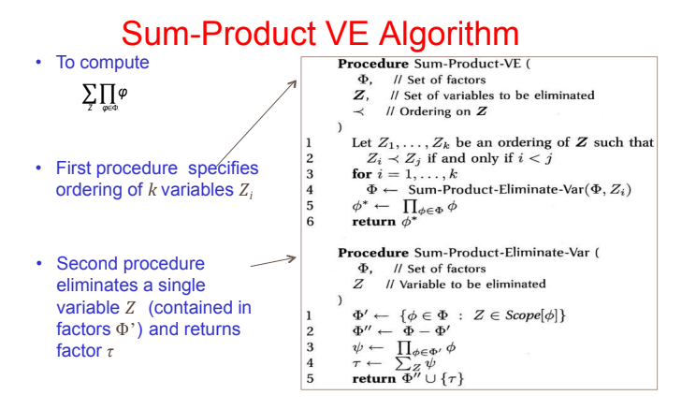

- function SumProductVE(Φ, Z):
- // Φ = list of all factors (like tables of numbers)
- // Z = list of variables we want to eliminate (sum over)

- while Z is not empty: // Keep going until all variables are gone
- pick next variable Z_i from Z // Choose one variable to eliminate now
- factors_with_Zi = all φ in Φ that include Z_i // Find all factors that depend on Z_i
- ψ = product of factors_with_Zi // Multiply those factors together → new big factor
- τ = sum out Z_i from ψ // Sum over all values of Z_i → remove Z_i
- remove factors_with_Zi from Φ // Remove the old factors we used
- add τ to Φ // Add the new factor (without Z_i) back
- remove Z_i from Z // Z_i is gone forever from the list
- end // Loop repeats with remaining variables

